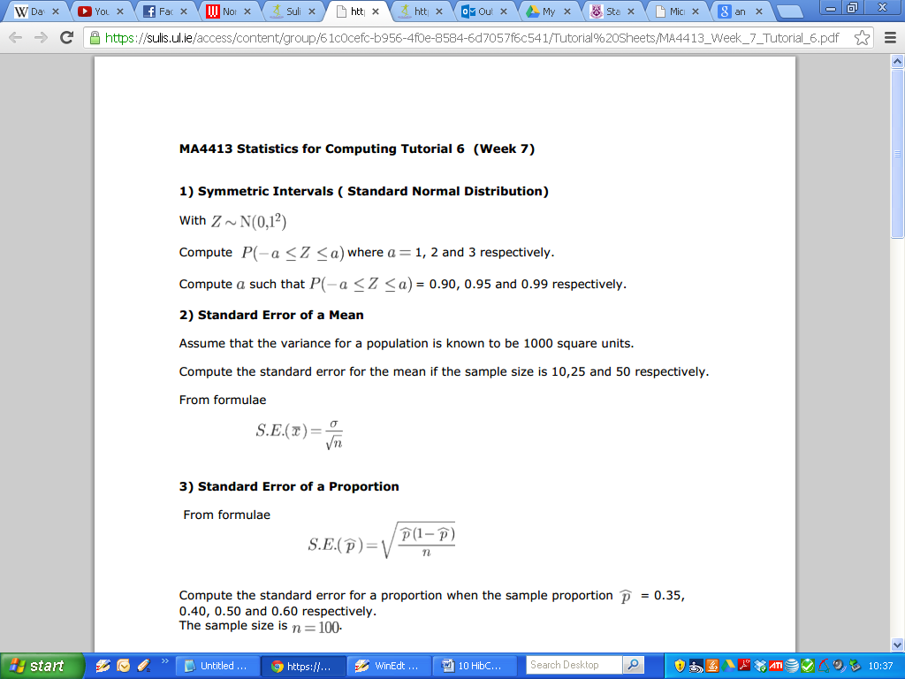

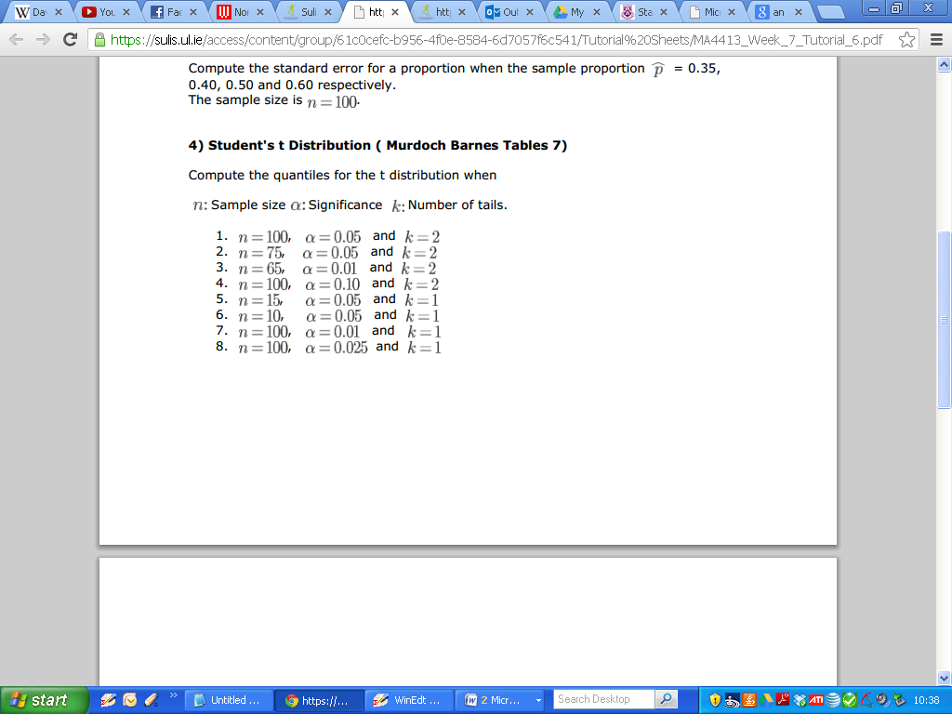

Q5. The standard deviation of test scores obtained for a certain exam is 18 points. A random sample of 81 students has a sample mean of 70 points.

(a) State the point estimate for the mean score for all the students.

(b) Find the 95% confidence interval for the average score for all students.

(c) Find the 99% confidence interval for the average score for all students.

Q6. The amount spent (€’s) by customers in a shop are normally distributed. A random sample of 16 customers have these values:

***19 21 35 29 12 35 7 18 21 14 29 2012 24 32 23***

(Sample mean of €21.94 and a sample standard deviation of €8.40)

Estimate a 95% confidence interval for the population mean.

Q7. The operating life of rechargeable cordless screwdrivers produced by a firm is assumed to the approximately normally distributed. A sample of 15 screwdrivers is tested and the mean life is found to be 8900 hours, with a sample standard deviation of 500 hours. Provide a 95% confidence interval for the population mean.

Q8. Of a sample of 500 computer programmers, 344 cited C as their primary programming language. Let π be the proportion of all computer programmers who regard C as their primary programming language. Estimate π and provide a 95% confidence interval for π.